**ASSESSMENT 2 :**

**Student : 74525**

**Sylvain GROSS**

Intro :

This mobile application is designed to show up four movies on the main page, and for each movie we can select several virtual seats or deselect it.

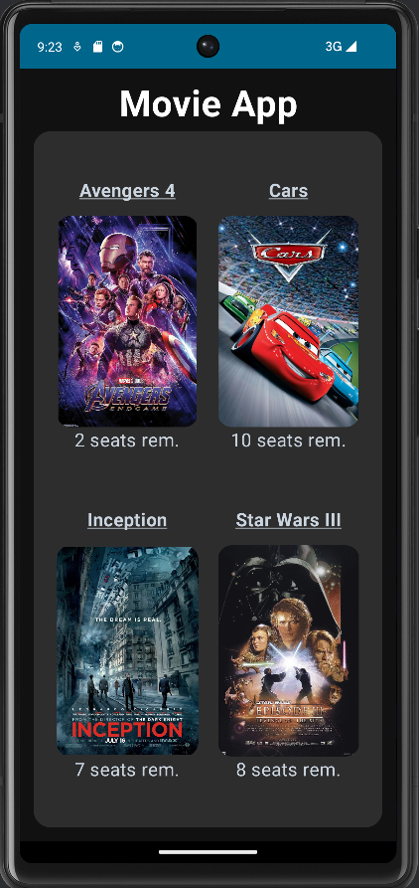

So I decided to make a simple App with simple colors, because I’m still a beginner in mobile application. I chose the movies randomly. I took a dark theme for the comfort of the user and rounded corners. The title “Movie App” will be the name of the application and the 4 little titles underlined are the name of the movies. I took poster pictures because for my point of view it is more convenient in our phone to have portrait photos rather than landscape photos. Under the picture there is the remaining seats available for each movie (it is a random number between 1 and 15).

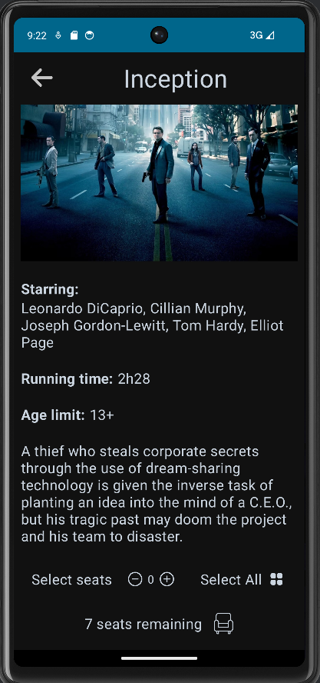When I click on the first movie this screen appears. We can see the landscape movie picture and the title. Below it there is the description of the film : the starring, running time and age limit. And then a little description of the movie, a synopsis. I put the starring, running time and age limit title in bold to make a contrast between the rest of the text. Under that, there is the possibility to select some seats from the remaining ones. Here there is 7 seats available.

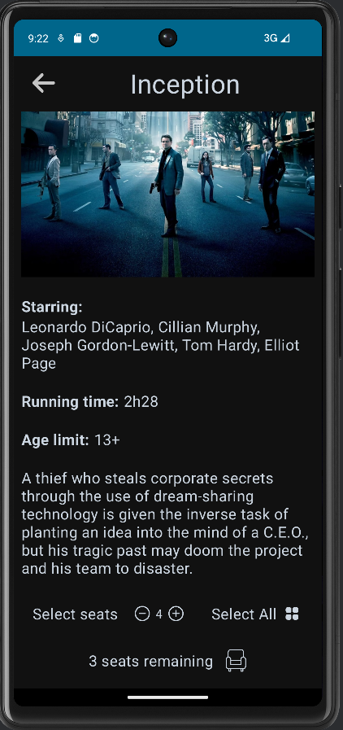I selected four seats and we can see that there is only 3 seats remaining now. I also have a “select all” button who obviously select all the remaining seats.

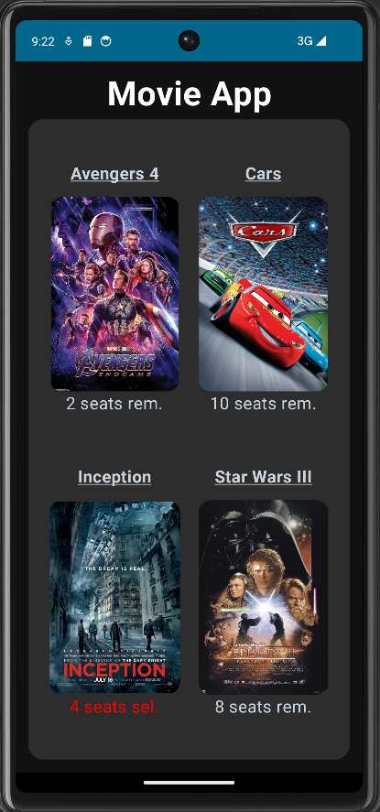

And finally when a come back to the main page with the left arrow on the top left corner, the text of the movie I was has changed and displays now the number of seats selected in red, so that the user can pay attention.

Design : I chose a simple design with dark theme to make the application simple to use. There is not too many colors and images.